W/B 1st June 2020 Year 1 weekly plan
 | English | Maths
Monday | Training day
Tuesday | Phonics focus this week- alternative ‘a’ sound (see Spelling list 1st June).  The letter ‘a’ can make an /a/ sound (hat), an /ai/ sound (angel), it can also make an ‘o’ sound in ‘what’. Practise these alternative pronunciations using the activities below.  Suggested Phonics activities to complete during the week:  - Play Obb and Bob. Follow link and press ‘phase 5’, ‘revise all phase 5’ https://new.phonicsplay.co.uk/resources/phase/5/picnic-on-pluto  - Look through the alternative ‘a’ PowerPoint and sound out the words.  - Sort the alternative ‘a’ word cards into 3 columns based on the sound they make. | https://whiterosemaths.com/homelearning/year-1/  Watch the white Rose Maths Video on ‘Measure Mass’ (Summer term- week 6, lesson 1) and complete the accompanying activity sheet. You can now download the accompanying sheets from our home learning page.  Challenge ideas: As an extra challenge you could have a go at some of the problem solving and reasoning challenges in the PowerPoint on our home learning page.
Wednesday | Traditional Tales  Read some traditional tales. You can use your own story books or try the ones on the list below. Who are the characters in the story? Where does the story take place? Are there any special objects? What goes wrong in the story? Once you have read a few complete the grid on the reading retrieval sheet. | Watch the white Rose Maths Video on ‘Compare Mass’ (Summer term- week 6, lesson 2) and complete the accompanying activity sheet.  Challenge ideas: See PowerPoint
Thursday | Using the stories you read yesterday, or even read some different ones, think about the characters. In traditional tales there are always goodies and baddies who are they in your stories? Do the stories take place in similar settings or are they all different? Look at the language used – is there something similar? How do they start (once upon a time)? How do they end (they all lived happily ever after)? Are there phrases that are repeated in the story (Ill huff and I’ll puff… Mirror mirror on the wall… Fe Fi Fo Fum…)  Using the Traditional tales features sheet make a list for each box – you can go back to it and add more whenever you read another traditional tale. | Watch the white Rose Maths Video on ‘Introduce Mass and Volume (Summer term- week 6, lesson 3) and complete the accompanying activity sheet.  Challenge ideas: See PowerPoint
Friday | Joined handwriting! Watch the video and practise the 3 joins (ai, am, an) using the ‘handwriting lines’.  Spelling dictation. Read the passage on the spelling sheet a sentence at a time to your child for them to copy into their home spelling book (see Spelling list 1st June). The passage incorporates the weekly spellings and other high frequency words. | Watch the white Rose Maths Video on ‘Measure Capacity’ (Summer term- week 6, lesson 4) and complete the accompanying activity sheet.  Challenge ideas: See PowerPoint

Traditional Tales
Many of you will have traditional stories at home. If you haven’t then there are books and stories you can read online.

Twinkl
There are many e books if you have a twinkl account. We have downloaded these – see Home learning page
The Three Little pigs
Hansel and Gretel

Look at the Oxford Owl website – type in traditional tales – there are a selection from different colour bands
Chicken Licken – Yellow
The Magic Paintbrush – Green
Frog Prince – Orange
Rumplestiltskin - Turquoise
Fin MacCool – Purple
East of the sun, West of the Moon – Gold

Storynory
Storynory have a good selection of traditional /fairy tales. The stories are narrated but there is also the text that the children could follow or read for themselves. Click on the link below.
https://www.storynory.com/archives/fairy-tales/

Theme | Science | Art | RE
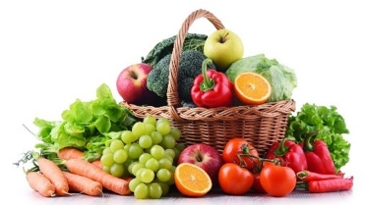  Where do fruit and vegetables come from?  How many fruit and vegetables can your child name. Use the photocards - can they identify them. Try sorting them into fruits and vegetables.  Watch the following videos to find out where fruits and vegetables come from.  https://www.youtube.com/watch?v=lYCP8lP_kQo  https://www.youtube.com/watch?v=CdPRZ3wjCxA  https://www.bbc.co.uk/teach/class-clips-video/william-whiskerson-orchard-fruit/z6xtscw  Watch the power point where do fruit and vegetables grow.  Use the flashcards again and decide if they grow on trees, bushes, stems, vines, on or under the ground.  Complete the worksheet Where do fruit and vegetables grow | 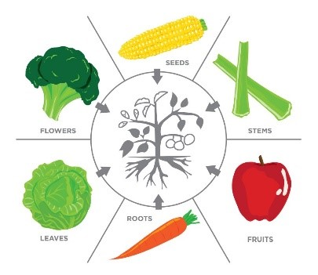  Which part of the plant do we eat?  Look at a plant in your garden/house can your child name the different parts. Which parts of a plant can be eaten?  Watch the power point - Which part of the plant do we eat? Use the photocards from yesterday and decide which part of the plant it is – fruit, seed, stem, leaf, flower or root.  Complete the worksheet – Plant parts we eat. Can you add one more of your own to each box?  You may also want to watch this to see what parts of the plant we eat.  https://www.youtube.com/watch?v=sdWzV2JxmNY  Here’s a song for you  https://www.youtube.com/watch?v=RE5tvaveVak | Drawing fruit and vegetables  Choose either a fruit or a vegetable. Look closely at the shape. Draw the outline. Can you see any lines or marks? Add any detail to your drawing. Try one in pencil then use colour (paint, pastel. crayons) Look really carefully at the shades of colour.  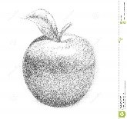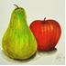  Try a few different fruits or vegetables.  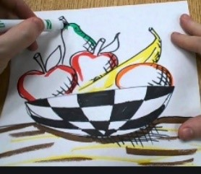  Have a go at drawing a still life fruit bowl. Arrange the fruit in a bowl. Look very carefully.  Look at a video to help you.  https://www.youtube.com/watch?v=l9k9bLfCCVA  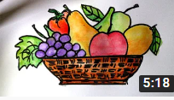  https://www.youtube.com/watch?v=8NvAjVUFqNA | What Objects are special to Sikh’s and why?  For the next 2 weeks we are going to look at objects special to Sikhs.  Christians have special objects, did you think a few weeks ago about which are special? Bible, cross, bread and wine, candle. These are just a few of them. Now we are going to think about some objects called the 5 K’s. watch this short video below following the link. Video Link Here  Now using this video and the power point in the resources section you can draw and name each object on the sheet included in the resources.  (I have put a reminder sheet as well to help with the spellings of each object.)  DEEPER THINKING: Which object could be dangerous and why?  Stick the completed sheet in your purple work book.

