W/B 18th May 2020 Year 1 weekly plan
 | English | Maths
Monday | Phonics focus this week- alternative ‘er’ sound (see Spelling list 18th May).  Watch Geraldine the Giraffe introduce the ‘er’ digraph that can make a long or short /er/ sound. https://www.youtube.com/watch?v=WaxZN4BZjgc  Suggested Phonics activities to complete during the week:  - Play the ‘er sound board game’ with a member of your family.  - Complete the ‘er digraph word search’  - Highlight all the ‘er’ words in the ‘er phoneme spotter’  - Play a game using the ‘er roll and read mat’  - Practise spellings in your spelling book | https://whiterosemaths.com/homelearning/year-1/  Watch the white Rose Maths Video on ‘Compare length & height’ (Summer term- week 5, lesson 1) and complete the accompanying activity sheet. You can now download the accompanying sheets from our home learning page.  Challenge ideas: Find some objects from around your house, can you order them from shortest to longest?
Tuesday | This week, in English and theme, you are going to find information about a dinosaur of your choice and then present your facts as creatively as you want.  Use the planning sheet – make notes – write key words/phrases not whole sentences.  First, get to know your dinosaur. Read as much information about it as you can find.  - What did your dinosaur look like? - how big was it, what shape was its body, were its legs long or short, did it have horns, plates, crests or claws, describe the teeth, head, neck, tail, etc. Did it walk on 2 legs or 4?  - What did the dinosaur eat and how did it get its food? Where was this dinosaur in the food chain? What features did it have to help catch its food e.g. long neck to reach leaves, sharp teeth to tear meat.  - How did it defend itself (and/or attack other animals)? What animals might have attacked it? Or what animals might it have preyed upon?  - What is special about your dinosaur? Did you find any other interesting facts?  SEE THEME FOR USEFUL WEBSITES TO FIND INFORMATION | Watch the white Rose Maths Video on ‘Measure length (1)’ (Summer term- week 5, lesson 2) and complete the accompanying activity sheet.  Challenge ideas: optional challenge questions are available on our home learning page.
Wednesday |  | Watch the white Rose Maths Video on ‘Measure length 2’ (Summer term- week 5, lesson 3) and complete the accompanying activity sheet.  Challenge ideas: Use a ruler to measure objects in your house. Can you estimate how long they will be?
Thursday |  | Watch the white Rose Maths Video on ‘Introduce weight and mass’ (Summer term- week 5, lesson 4) and complete the accompanying activity sheet.  Challenge ideas: optional challenge questions are available on our home learning page.
Friday | Joined handwriting! Watch the video and practise the 3 joins (ds, di, du) using the ‘handwriting lines’.  Spelling dictation. Read the passage on the spelling sheet a sentence at a time to your child for them to copy into their home spelling book (see Spelling list 18th May). The passage incorporates the weekly spellings and other high frequency words. | Complete the ‘Friday maths challenge’ (Summer term- week 5, lesson 5).

Theme | Science | Art | PSHE
Dinosaur research  Watch this video to find out about dinosaurs.  https://www.bbc.co.uk/cbeebies/curations/dinosaur-facts  These websites will help you to find information and facts about your dinosaur.  https://www.dkfindout.com/uk/dinosaurs-and-prehistoric-life/dinosaurs/  https://www.nhm.ac.uk/discover/dino-directory.html  https://www.sciencekids.co.nz/sciencefacts/dinosaurs.html  https://www.kids-dinosaurs.com/dinosaur-t-rex.html  For information on particular dinosaurs, try these as well Dinosaur Information Sheets, Dinosaur fact sheets, or Dinosaur Printouts.  Now you have all your information have a think about how you will present it. Use your imagination!  You could:  - write a report  - create a poster/leaflet  - make a book – lift the flap  - do a piece of art and attach the information  - Draw a large dinosaur and write the facts inside | Dinosaur Habitats  Choose one of the activities below  Discuss with the children what a habitat is – a place where an animal lives. How many habitats can you name? – make a list. Explain to the children that they are going to create a dinosaur habitat for their dinosaur to live in. Discuss what will be needed (food, shelter, water) and what other creatures will need to be there too – think back to work on food chains. You could make a habitat for your dinosaur outside by collecting materials such as sticks, leaves, soil, stones moss etc. You could collect the things and create a habitat in a box. 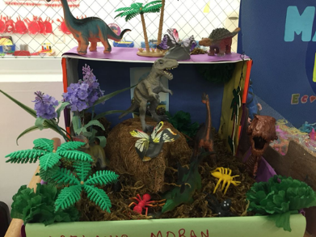  Or  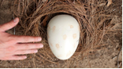  Imagine you have found a dinosaur egg – you are worried about how to look after this tiny baby. Think about how you look after your own pets by giving them somewhere warm to sleep, food to eat etc. Then gather everything that you might need to take care of your new dinosaur. Write instructions on how to look after your dinosaur egg. | Fossil art  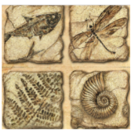  This week we are going to continue with the theme of fossils. Try creating a fossil picture in string. Create prints onto paper. Try using different papers and drawing media – charcoal, chalk on black, sepia colours on beige.  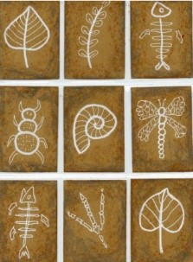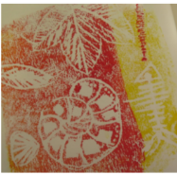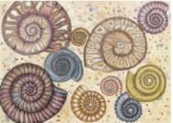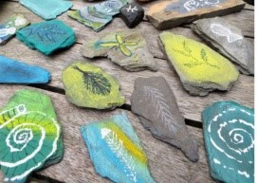  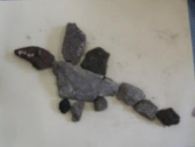  Draw fossil designs on flat stones using chalk or have a go at creating a dinosaur from stones. Take a photo of your work and stick in your book. | What can we do to keep healthy?  This week we are going to access Harold’s Diary again.  Click on the link below to access the resources. Choose one for your child to do.  Harold's Daily Diary 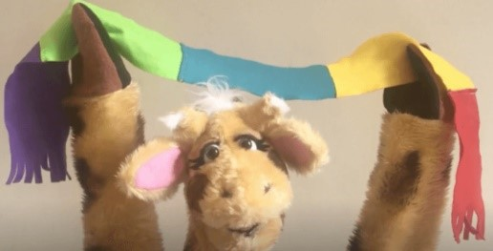  Each day, Harold's diary gets children to think about the different things they need to keep healthy - physically and emotionally. There are ideas for activities, pictures and other resources.  It is also kindness week. Click on the link below to access the kindness activities.  https://coramlifeeducation.us16.list-manage.com/track/click?u=d6e14545cf5bc5c9bf48ceaae&id=b9fca19949&e=7ceebc47b5

