Year 1 weekly plan
W/B 11th May 2020
 | English | Maths
Monday | Phonics focus this week- alternative ‘ea’ sound (see Spelling list 11th May).  Watch Geraldine the Giraffe introduce the ‘ea’ digraph that makes the /e/ sound.  https://www.youtube.com/watch?v=oJi0kan0mBs  Suggested Phonics activities to complete during the week:  - Play Dragon’s Den. Follow link and press ‘Phase 5’, ‘Revise all phase 5’.  https://new.phonicsplay.co.uk/resources/phase/5/dragons-den  - Complete the ‘Find and write the ‘ea’ words’ sheet.  - Play ‘A treat by the sea’ and ‘Wet weather fun’ on Education City. These games have been added to your phonics Mycity page.  - Practise spellings in your spelling book | https://whiterosemaths.com/homelearning/year-1/  Watch the white Rose Maths Video on ‘Add by making 10’ (Summer term- week 4, lesson 1) and complete the accompanying activity sheet. You can now download the accompanying sheets from our home learning page.  Challenge ideas: optional challenge questions are available on our home learning page.
Tuesday | Think about what you know about Mary Anning already.  Draw a picture of her and think of some adjectives to describe her. Was she... clever, curious, brave? | Watch the white Rose Maths Video on ‘Subtract within 20’ (Summer term- week 4, lesson 2) and complete the accompanying activity sheet.  Challenge ideas: optional challenge questions are available on our home learning page.
Wednesday | Watch the Mary Anning video up to the point when Mary uncovered the ichthyosaur - https://www.bbc.co.uk/programmes/p015gn89  Imagine you are Mary. You have just spent weeks working on the fossil and uncovered an unusual creature you haven't seen before. You are so excited that you must tell someone about it! So you decide to write to a friend. Imagine you are going to write a letter to a friend explaining what you have found. On your plan try think of answers to these questions;  Where were you when you made your discovery?  How did you manage to uncover the fossil? Did you have help?  How did you feel when you realised what you had found?  What did you think it might be? | Watch the white Rose Maths Video on ‘Add and subtract word problems’ (Summer term- week 4, lesson 3) and complete the accompanying activity sheet.  Challenge ideas: optional challenge questions are available on our home learning page.
Thursday | Using your plan begin to write a letter. How will you begin your letter? Have a look at the WAGOLL in the resources section. Can you spot anything you’d like to magpie? Remember to try to use words like ‘and’, ‘but’ and ‘because’ to extend your sentences. Could you use a question mark or exclamation mark like you did last week?  This will be different from the biography you wrote last week because you are writing it from Mary Anning’s point of view. Remember to add interesting details about how you felt about your discovery. You might also want to add a drawing of your discovery. | Watch the white Rose Maths Video on ‘Compare number sentences’ (Summer term- week 4, lesson 4) and complete the accompanying activity sheet.  Challenge ideas: optional challenge questions are available on our home learning page.
Friday | Joined handwriting! Watch the video and practise the 3 joins (aq, da, do) using the ‘handwriting lines’.  Spelling dictation. Read the passage on the spelling sheet a sentence at a time to your child for them to copy into their home spelling book (see Spelling list 11th May). The passage incorporates the weekly spellings and other high frequency words. | Complete the ‘Friday maths challenge’ (Summer term- week 4, lesson 5).

Theme | Science | Art | RE
Where in the world did the dinosaurs live?  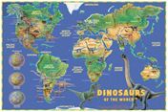  Explain that dinosaur fossils have been found all over the world. By learning the age of fossils and examining them, palaeontologists can find out information about people, plants, animals –including dinosaurs, that lived before us Show a world map. Name the continents. Explain that continents were once all connected into one land mass called Pangea when the dinosaurs lived. Over time parts of Pangea drifted apart to form the continents.  Where do the children think dinosaurs may have lived?  Use the dinosaur pictures (see sheets) – cut out and place on the map of the world. | What is a food chain?  Watch the BBC bitesize video to learn about food chains.  https://www.bbc.co.uk/bitesize/clips/z96r82p  Now have a look at the Food Chains PowerPoint. This will teach you what the words ‘producer’ and ‘consumer’ mean, as well as how to use arrows in a food chain.  Complete the dinosaur food chains worksheet- there are two food chains to complete. You also might like to create your own food chain using different dinosaurs! | What do fossils look like?  Do you have any fossils at home? Look closely at them or find a picture of a fossil from a book or the internet.  Make a careful observational drawing of a fossil. Look carefully at the lines.  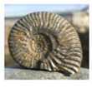  You can have a go at making your own fossil video Watch the ‘making a fossil’ video below  https://www.bbc.co.uk/cbeebies/makes/presenters-making-a-fossil  There is also a separate recipe on our home learning page ‘Making a fossil’. | What objects are special to Christians?  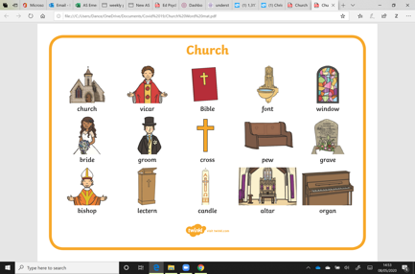  Have a look at these pictures and circle which ones you think are special to Christians.  Then have a talk to your mum or dad and tell them why you think they are special to Christians.  Next stick the sheet in your learning book and then choose your favourite 2 pictures and write a sentence telling me why they are special to Christians.  Your mum or dad might like to write a comment about the other things you discussed during your reflecting/sharing time.

