Year 2 weekly plan W/B 18th^{th} May 2020
 | English | Maths
Monday | Spellings for this week – suffixes ful and less (see list)  Watch the power point and complete the activity sheets. | Lesson 1 - Multiplication sentences using the x symbol. Watch video  Summer term week 5 lesson 1 then do accompanying sheets.  https://whiterosemaths.com/homelearning/year-2/
Tuesday | Reading – Read the e book on Dinosaurs. Read once to ensure you can read all the words. Then read again - this time with more fluency and ensuring you understand what you are reading. When you have finished do the quiz on page 25-26. | Lesson 2 – Multiplication sentences from pictures.  (See attached worksheets)
Wednesday | This week, in English and theme, you are going to find information about a dinosaur of your choice and then present your facts as creatively as you want.  Use the planning sheet – make notes – write key words/phrases not whole sentences.  First, get to know your dinosaur. Read as much information about it as you can find. What did your dinosaur look like? - how big was it, what shape was its body, were its legs long or short, did it have horns, plates, crests or claws, describe the teeth, head, neck, tail, etc. Is there anything special about this dinosaur? How did its anatomy affect its life? For example: a giant sauropod had to eat a lot but didn't have to worry much about protecting itself, a tiny dinosaur probably had to run fast to escape being eaten for dinner, an armoured dinosaur didn't have to be fast, but did have to avoid being flipped over, and so on.  What did the dinosaur eat and how did it get its food? Where was this dinosaur in the food chain?  How did it walk (2 or 4 legs - slow or fast locomotion)?  What is known about your dinosaur's behaviour, if anything? For example: Is there evidence of herding? Did it nurture its young? Have any nests or eggs been found? How did your dinosaur rate in terms of intelligence?  How did it defend itself (and/or attack other animals)?  What animals might have attacked it? Or what animals might it have preyed upon?  When did your dinosaur live?  SEE THEME FOR USEFUL WEBSITES TO FIND INFORMATION | Lesson 3 – Make equal groups -sharing  (See attached worksheets)
Thursday |  | Lesson 4 – Make equal groups – grouping  (See attached worksheets)
Friday | Spelling dictation (see download sheet) Read the passage a sentence at a time to your child for them to copy into their blue spelling book. The passage incorporates the weekly spellings and other high frequency words. | Complete the ‘Friday maths challenge’ on the White Rose Maths Hub (Summer term- week 5, lesson 5).  https://whiterosemaths.com/homelearning/year-2/

Theme | Science | Art | PSHE
Dinosaur Research  Watch this video to find out about dinosaurs.  https://www.bbc.co.uk/cbeebies/curations/dinosaur-facts  These websites will help you to find informations and facts about your dinosaur.  https://www.dkfindout.com/uk/dinosaurs-and-prehistoric-life/dinosaurs/  https://www.nhm.ac.uk/discover/dino-directory.html  https://www.sciencekids.co.nz/sciencefacts/dinosaurs.html  https://www.kids-dinosaurs.com/dinosaur-t-rex.html  For information on particular dinosaurs, try these as well Dinosaur Information Sheets, Dinosaur fact sheets, or Dinosaur Printouts  Now you have all your information have a think about how you will present it. Use your imagination!  You could: write a report  - create a poster/leaflet  - make a book – lift the flap  - do a piece of art and attach the information  - Draw a large dinosaur and write the facts inside  - Create a video presentation | Dinosaur Habitats  Discuss with the children what a habitat is – a place where an animal lives. How many habitats can you name? – make a list.  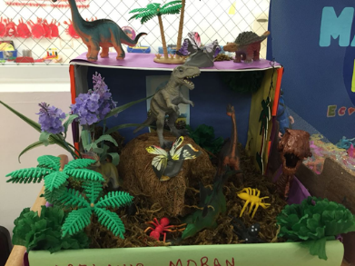  Explain to the children that they are going to create a dinosaur habitat for their dinosaur to live in. Discuss what will be needed (food, shelter, water) and what other creatures will need to be there too – think back to work on food chains. You could make a habitat for your dinosaur outside by collecting materials such as sticks, leaves, soil, stones moss etc. You could collect the things and create a habitat in a box.  Or you could do this task -  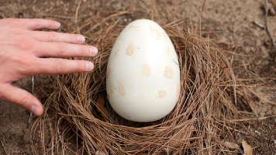  Imagine you have found a dinosaur egg – you are worried about how to look after this tiny baby. Think about how you look after your own pets by giving them somewhere warm to sleep, food to eat etc  Gather everything that you might need to take care of your new dinosaur. You can even made him a special cosy den - think about camouflage!  Write the instructions to look after your dinosaur egg. | Dinosaur/Fossil Art  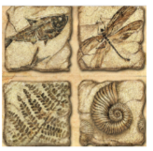  This week we are going to continue with the theme of fossils. Try creating a fossil picture in string. Create prints onto paper. Try using different papers and drawing media – charcoal, chalk on black, sepia colours on beige.  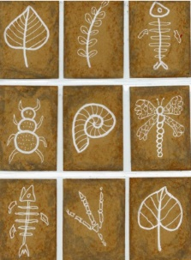  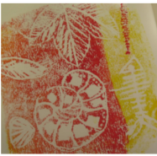  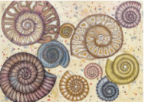  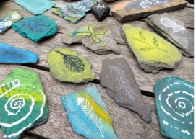  Draw fossil designs on flat stones using chalk.  Have a go at creating a dinosaur from stones.  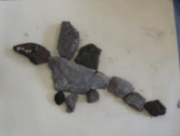  Take a photo of your work and stick in your book.  See other ideas below. | What can we do to keep healthy?  This week we are going to access Harold’s Diary again.  Click on the link below to access the resources. Choose one for your child to do.  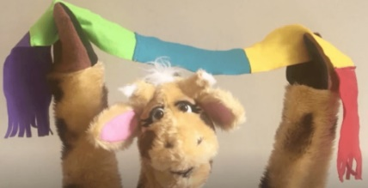  Harold's Daily Diary  Each day, Harold's diary gets children to think about the different things they need to keep healthy - physically and emotionally. There are ideas for activities, pictures and other resources.  It is also kindness week. Click on the link below to access the kindness activities.  https://coramlifeeducation.us16.list-manage.com/track/click?u=d6e14545cf5bc5c9bf48ceaae&id=b9fca19949&e=7ceebc47b5

