Year 2 weekly plan W/B 4th^{th} May 2020
 | English | Maths
Monday | Spellings for this week – suffixes er est (see list)  You can watch the following to help you with adding er and est (ignore homework task at end)  https://www.youtube.com/watch?v=R7VLVi2hu6g  There is also a powerpoint version of this– see download  Now complete activity sheets. | Make patterns with 2D shapes  See download lesson 11  Challenge – can you create your own 2D shape sequence?
Tuesday | Make sure you have done the theme lesson on Mary Anning – it will help you with your English  English biography plan - see sheet  After watching Mary Anning’s life story in this week’s theme lesson- use these facts to plan a biography of Mary Anning. (A biography is the story of someone’s life) Look at your facts and add the information to the correct part of her life. Remember they are only notes/facts so they do not need to be written in proper sentences. Watch the videos again if you need a reminder. | Make patterns with 3D shapes  See download lesson 12  Challenge – can you create your own 3Dshape sequence?
Wednesday | Mary Anning - Biography  Use yesterday’s plan to write a biography of Mary Anning. Now turn the facts into sentences.  Begin with an introduction. Who was she and what was she famous for? Move on to saying what happened in her life. Use the sections of your plan as a guide to the order you should write it in.  End with a sentence about how famous she became and what she did for science and the discovery of fossils and dinosaurs. Don’t forget all the things you need for a good piece of writing.  If you want, you can draw pictures or print off pictures to go with your writing. | Fact families  Watch the white Rose Maths Video - Summer term- week 3, lesson - complete the accompanying activity sheet.  https://whiterosemaths.com/homelearning/year-2/
Thursday | Guided reading - read the story of Mary Anning then answer the questions – keep checking the text to look for key words. | Related facts  Watch the white Rose Maths Video Summer term- week 3, lesson 3  https://whiterosemaths.com/homelearning/year-2/
Friday | Spelling dictation (see download sheet) Read the passage a sentence at a time to your child for them to copy into their blue spelling book. The passage incorporates the weekly spellings and other high frequency words.  VE day activities  VE Day is Victory in Europe Day. It marks the end of World War II in Europe on 8th May 1945, when the Nazi forces officially surrendered to the Allies. The day was a public holiday, where people sang and danced outside their homes, and held street parties, although World War II didn't officially end until 2nd September 1945, when the Japanese formally surrendered.  Have a go at some of the different activities below. | Add and Subtract 1s  Watch the white Rose Maths Video Summer term- week 3, lesson 4  https://whiterosemaths.com/homelearning/year-2/

Theme | Science | VE Day activities
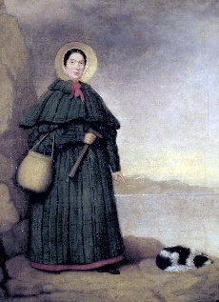  Who is Mary Anning?  Please try to complete this week’s theme activity before Tuesday’s English lesson.  How do we know dinosaurs existed? Discuss this with your child. Encourage them to think about the discovery of fossils and palaeontology.  Watch Mary Anning’s life story on BBC  https://www.bbc.co.uk/teach/class-clips-video/true-stories-mary-anning/zn7gd6f  Use the sheet – What do we know about Mary Anning? Write down as many facts as you can remember from the video.  Now try watching this video and see if you can add any more information.  https://www.youtube.com/watch?v=Of5sK8p2rZY  You can also watch this if you want to find more facts.  https://www.youtube.com/watch?v=u9Nb543MvV0 | What is a fossil?  Watch BBC Bitesize video on how fossils are made  https://www.bbc.co.uk/bitesize/topics/z9bbkqt/articles/z2ym2p3  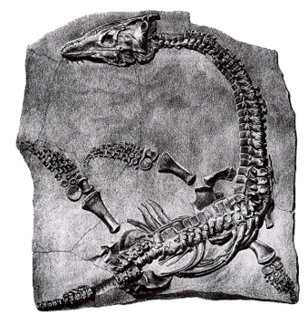  Talk about how Mary Anning found her fossils and how they have been finding fossils for years.  https://www.bbc.co.uk/teach/class-clips-video/geography-ks1-ks2-fossil-hunting-along-the-jurassic-coast/zbbrkmn  Watch this video to help you with the activity on What are fossils?  https://www.youtube.com/watch?v=3rkGu0BItKM  Read the sheet What are fossils? Cut out the pictures and match to the description to show the formation of a fossil. | 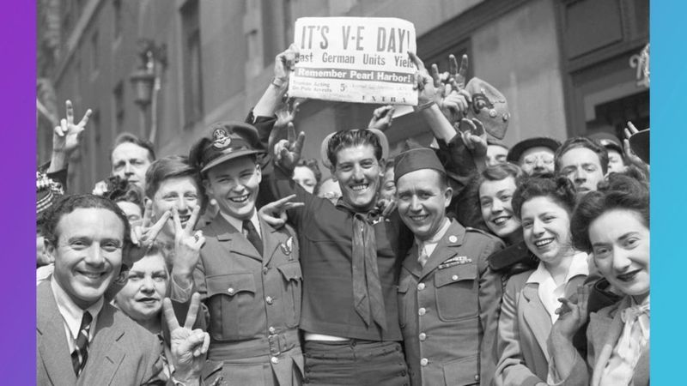  What is VE Day?  Choose as may of the activities below as you want.  Watch the power point explaining what happened that day.  Make a WW2 spitfire glider.  Complete the VE day wordsearch.  Make something from the wartime recipe booklet.  Design a VE day medal or teacup.  Crack the code – using Morse Code.  Plan a VE street party celebration -You can make your own paper bunting.

