Year 2 weekly plan W/B 1st June 2020
 | English | Maths
Monday |  | If you look at summer term week 6 they have videos on sharing and grouping. We sent the worksheets home before half term but these videos can be watched and the activities done on paper.
Tuesday | Spellings – vowels that sound different – see spellings sheet. | Watch video – (Summer term week 6 - lesson 2)  https://whiterosemaths.com/homelearning/year-2/  Complete division by sharing worksheet
Wednesday | Traditional Tales  Read some traditional tales. You can use your own story books or try the ones on the list below. Who are the characters in the story? Where does the story take place? Are there any special objects? What goes wrong in the story? Once you have read a few complete the grid on the reading retrieval sheet. | Watch video – (Summer term week 6 - lesson 3)  https://whiterosemaths.com/homelearning/year-2/  Complete division by grouping worksheet
Thursday | Using the stories you read yesterday, or even read some different ones, think about the characters. In traditional tales there are always goodies and baddies who are they in your stories? Do the stories take place in similar settings or are they all different? Look at the language used – is there something similar? How do they start (once upon a time)? How do they end (they all lived happily ever after)? Are there phrases that are repeated in the story (Ill huff and I’ll puff… Mirror mirror on the wall… Fe Fi Fo Fum…)  Using the Traditional tales features sheet make a list for each box – you can go back to it and add more whenever you read another traditional tale. | Quick recall – see division sheets  How fast can you complete a column? Time yourself and see if you can beat your time on the next column.  Have a go at the interactive - beat the clock  http://www.snappymaths.com/multdiv/2xtable/interactive/newlook/2xtablebtcd.htm  http://www.snappymaths.com/multdiv/5xtable/interactive/newlook/5xtablebtcd.htm  http://www.snappymaths.com/multdiv/10xtable/interactive/newlook/10xtablebtcd.htm
Friday | Handwriting – Copy out the passage in your best joined writing – you can add a drawing at the bottom if you want. Think about the size of your letters - make sure the tall letters are tall.  Spelling dictation (see download sheet) Read the passage a sentence at a time to your child for them to copy into their blue spelling book. The passage incorporates the weekly spellings and other high frequency words. | Complete the ‘Friday maths challenge’ on the White Rose Maths Hub (Summer term- week 6, lesson 5).  https://whiterosemaths.com/homelearning/year-2/

Traditional Tales
Many of you will have traditional stories at home. If you haven’t then there are books and stories you can read on line.

Twinkl
There are many e books if you have a twinkl account. We have downloaded these – see Home learning page
The Three Little pigs
Hansel and Gretel

Look at the Oxford Owl website – type in traditional tales – there are a selection from different colour bands
Chicken Licken – Yellow
The Magic Paintbrush – Green
Frog Prince – Orange
Rumplestiltskin - Turquoise
Fin MacCool – Purple
East of the sun, West of the Moon – Gold

Storynory
Storynory have a good selection of traditional /fairy tales. The stories are narrated but there is also the text that the children could follow or read for themselves. Click on the link below.
https://www.storynory.com/archives/fairy-tales/

Theme | Science | Art | R.E
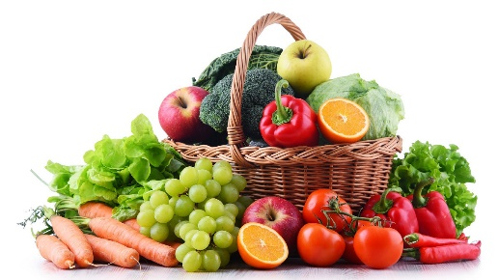  Where do fruit and vegetables come from?  How many fruit and vegetables can your child name. Use the photocards - can they identify them. Try sorting them into fruits and vegetables.  Watch the following videos to find out where fruits and vegetables come from.  https://www.youtube.com/watch?v=lYCP8lP_kQo  https://www.youtube.com/watch?v=CdPRZ3wjCxA  https://www.bbc.co.uk/teach/class-clips-video/william-whiskerson-orchard-fruit/z6xtscw  Watch the power point where do fruit and vegetables grow.  Use the flashcards again and decide if they grow on trees, bushes, stems, vines, on or under the ground.  Complete the worksheet Where do fruit and vegetables grow | 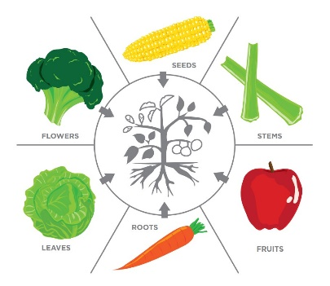  Which part of the plant do we eat?  Look at a plant in your garden/house can your child name the different parts. Which parts of a plant can be eaten?  Watch the power point - Which part of the plant do we eat? Use the photocards from yesterday and decide which part of the plant it is – fruit, seed, stem, leaf, flower or root.  Complete the worksheet – Plant parts we eat. Can you add one more of your own to each box?  You may also want to watch this to see what parts of the plant we eat.  https://www.youtube.com/watch?v=sdWzV2JxmNY  Here’s a song for you  Vegetable song  https://www.youtube.com/watch?v=RE5tvaveVak | Drawing fruit and vegetables  Choose either a fruit or a vegetable. Look closely at the shape. Draw the outline. Can you see any lines or marks? Add any detail to your drawing. Try one in pencil then use colour (paint, pastel. crayons) Look really carefully at the shades of colour.  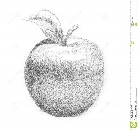  Try a few different fruits or vegetables.  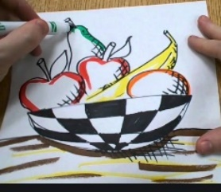  Have a go at drawing a still life fruit bowl. Arrange the fruit in a bowl. Look very carefully.  Look at a video to help you.  https://www.youtube.com/watch?v=l9k9bLfCCVA  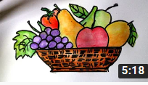  https://www.youtube.com/watch?v=8NvAjVUFqNA | How do Muslims celebrate Ramadan?  Muslims have just celebrated Ramadan. During this time most Muslims fast. This means they are not allowed to eat or drink during daylight hours. When fasting, they feel hungry and thirsty, which reminds Muslims of people in the world who are less fortunate than themselves. They begin to understand what it must be like for people who don’t have much to eat and because of this, many give money to the poor.  Watch the power point on Ramadan. Have a go at completing some of the activities for the kindness calendar – you can even add some of your own.  You can also read Rameena’s  e-story about kindness during Ramadan.  Other activities for you to try  You could have a go at making a Ramadan paper plate moon and star or a Sadaqah jar

