Year 2 weekly plan W/B 11th May 2020
 | English | Maths
Monday | This week we are looking at high frequency words – see spelling list | Complete ‘Adding two-digit numbers – bridging 10’ worksheet. Try each method before choosing your favourite method. Remember to show your working.
Tuesday | Watch the Mary Anning video up to the point when Mary uncovered the ichthyosaur https://www.bbc.co.uk/teach/class-clips-video/true-stories-mary-anning/zn7gd6f  Imagine you are Mary. You have just spent weeks working on the fossil and uncovered an unusual creature you haven't seen before. How did you feel when you realised what you had found? You are so excited that you must tell someone about it! So, you decide to write to Annie Philpot to tell her about your discovery! Complete the planning sheet. | Watch the White Rose Maths Video on ‘Add 2 -digit numbers’ (Summer term- week 4, lesson 2) and complete the accompanying activity sheet. Practise the methods used from yesterday to help you.  https://whiterosemaths.com/homelearning/year-2/  Challenge – can you make your own missing digits number sentence to challenge your siblings or parents.
Wednesday | Using your plan begin to write a letter. Remember you are writing it as if you were Mary so you will be using I and we. How will you begin your letter? Who is it to? Why are you writing to her? What do you want to tell her? How did you manage to do it? Would you like her to come and see it? Who else may want to see it? Could you sell it to a museum?  Remember to add interesting details about how you felt about your discovery. You might also want to add a drawing of your discovery. | Complete ‘Subtracting two-digit numbers’ worksheet. Recap each method before choosing your favourite method. Remember to show your working.
Thursday | Guided reading - read the information sheet ’How do we know about dinosaurs?’ then answer the questions – keep checking the text to look for key words. | Watch the White Rose Maths Video on ‘Subtract 2-digit numbers’ (Summer term- week 4, lesson 3) and complete the accompanying activity sheet. Practise the methods used from yesterday to help you.  https://whiterosemaths.com/homelearning/year-2/
Friday | Handwriting - Copy out the information on How do we know about dinosaurs? in your best joined writing – you can add a drawing at the bottom if you want. Think about the size of your letters - make sure the tall letters are tall.  Spelling dictation (see download sheet) Read the passage a sentence at a time to your child for them to copy into their blue spelling book. The passage incorporates the weekly spellings and other high frequency words. | Complete the ‘Friday maths challenge’ on the White Rose Maths Hub (Summer term- week 4, lesson 5).  https://whiterosemaths.com/homelearning/year-2/

Theme | Science | Art | R.E
Where in the world did the dinosaurs live?  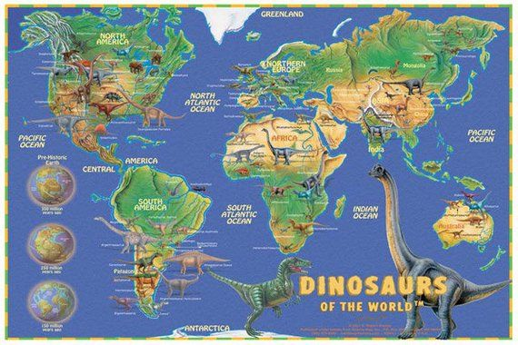  Explain that dinosaur fossils have been found all over the world. By learning the age of fossils and examining them, palaeontologists can find out information about people, plants, animals –including dinosaurs, that lived before us Show a world map. Name the continents. Explain that continents were once all connected into one land mass called Pangea when the dinosaurs lived. Over time parts of Pangea drifted apart to form the continents.  Where do the children think dinosaurs may have lived?  Use the dinosaur pictures (see sheets) – cut out and place on the map of the world. | What is a food chain?  Watch the BBC bitesize video to learn about food chains.  https://www.bbc.co.uk/bitesize/clips/z96r82p  Now have a look at the Food Chains PowerPoint. This will teach you what the words ‘producer’ and ‘consumer’ mean, as well as how to use arrows in a food chain.  Complete the dinosaur food chains worksheet- there are two food chains to complete. You also might like to create your own food chain using different dinosaurs!  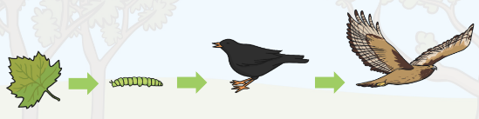 | What do fossils look like?  Do you have any fossils at home? Look closely at them or find a picture of a fossil from a book or the internet.  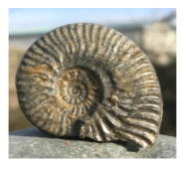  Make a careful observational drawing of a fossil. Look carefully at the lines.  You can have a go at making your own fossil. Watch the ‘making a fossil’ video  https://www.bbc.co.uk/cbeebies/makes/presenters-making-a-fossil  There is also a separate recipe on our home learning page ‘Making a fossil’. | What is it like in a Mosque?  Watch the video clip below to see what happens in a mosque.  How similar/different is it to a church?  https://www.youtube.com/watch?v=Q4J6SjgJ4sc  Watch the power point about worshipping in a mosque and complete the sheet identifying the features of a mosque.  Can you write a sentence about each one?  