Where in the world have dinosaurs been found?
Cut out each of the dinosaur boxes and place on the map of the world. Draw a line to the continent it belongs to.
Challenge – can you be even more accurate and find the actual country it was found in.
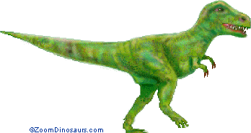  Tyrannosaurus rex  USA North America | 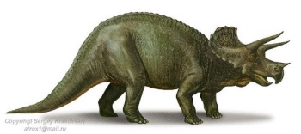  Triceratops  Canada North America | 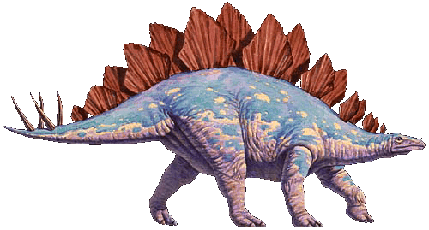  Stegosaurus  USA North America
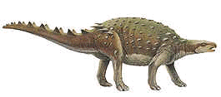  Dracopelta  Portugal Europe | 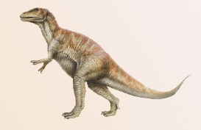  Megalosaurus  England Europe | 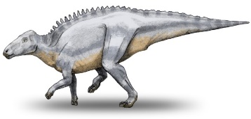  Telmatosuarus  Romania Europe
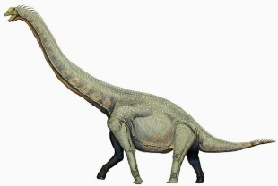  Barosuarus  India Asia | 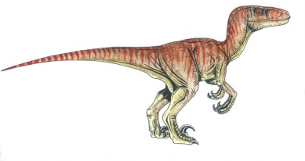  Velociraptor  China Asia | 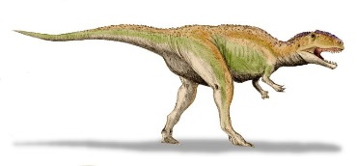  Gigantosaurus  Argentina South America
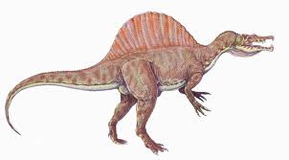  Spinosaurus  Morocco Africa | 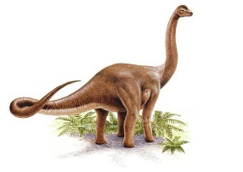  Austrosaurus  Australia Oceania | 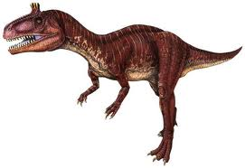  Cryolophosaurus  Antarctica

Can you add any of your own dinosaurs to the map?

