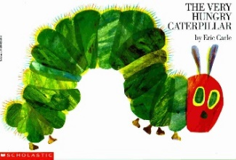
Foundation Home Learning Plan Week Beginning 11th May, 2020

Hello Parents and Children!
We have decided to continue with the theme of insects and learn all about caterpillars! We will be looking at the story of ‘The Very Hungry Caterpillar’. A story that will you know very well, I am sure! We have tried to make sure the activities are fun and interactive so that all the family can get involved with the learning. If you go on a hunt in the garden or when you are out on a walk you might find some caterpillars and insects hiding away from the sunshine. Go on have a look! We will continue to look at the different digraphs and consonant clusters in phonics. Hope you are all well and not missing us too much! Remember, please use this planning merely as a guide and dip in and out of it as you wish! Use the links to see the resources.

Activity 1 Daily Phonics.  At the start of daily phonics sessions, please recap all letter sounds and action words in their books, especially the harder ones! |  |  | Activity 2 |  | Activity 3
Mon | Focus on the sound ‘ai’  Watch the video all about the digraph ‘ai’.  https://www.youtube.com/watch?v=siVkXoEQDNc&list=PLuGr6z2H2KNG4XgGr7UylwowIcDLr-T-k&index=16  After the video, you could wrote these words on big pieces of paper and spread them across the floor. Using a splatter {wooden spoon}, Mum or Dad to shout out a word and child to hit the word with a spoon as quick as they can! |  | Literacy  Listen to the story ‘The Very Hungry Caterpillar’ read by Mrs. Atkinson on the All Saints’ website. After reading the story, close the book. Can you remember all the different foods that the caterpillar ate? Can you write them in the correct order? It might be hard to remember, you might have to take another look inside the book to check! {apple, banana, strawberries…???} Refer to the list on website |  | Topic - Expressive Arts & Design  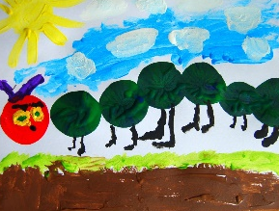  Can you find some felt tip pens, paint or chalks and draw all the wonderful foods the caterpillar ate. You could even paint a very large and hungry caterpillar using different greens and yellows.  You could even paint a very  beautiful butterfly! Put  It in your window in the  sunshine!
Tues | Focus on the sound ‘ee’  Watch the video all about the digraph ‘ee’.  https://www.youtube.com/watch?v=hBFFUCraDt8&list=PLuGr6z2H2KNG4XgGr7UylwowIcDLr-T-k&index=15  After watching the video, can you write a list of all the words with ‘ee’ in them?  Feet, meet, seem, feel, peel, been, cheep, sheep, greet. |  | Numeracy- adding 2 groups  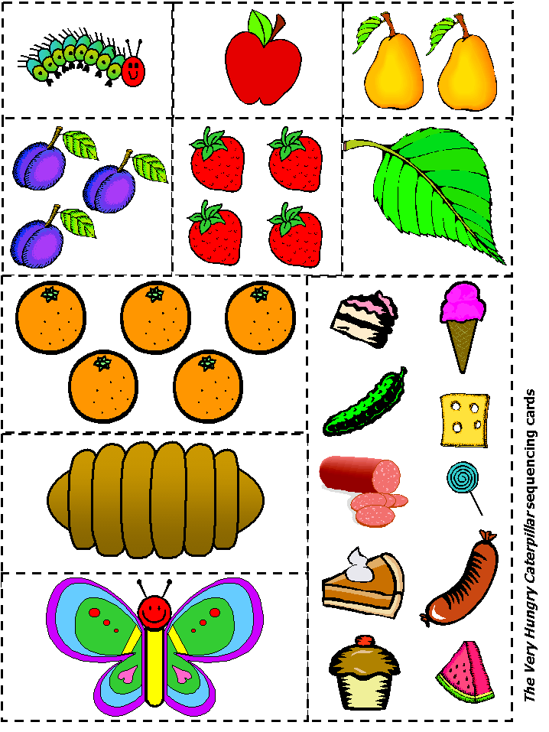  Make your own number stories up using food from your kitchen. You could  cut out your own foods and  place them in to 2 groups:  ‘5 oranges and 1 strawberry  Is 6 altogether’.  ‘2 pears and 3 plums is 5  altogether’ – you can say this  to help the understanding of  adding 2 groups together. Ask your child to make their own adding story.  Refer to adding worksheet on website |  | Literacy – act it out! A little bit of role play!!  Tell the story without looking at the book. What happens first? What does the caterpillar eat first? Then what does he eat? Can you act it out and pretend to be the caterpillar?  Make sure you use your expressive voice to tell the story!  Can Mummy and Daddy listen to your telling of the story?  Have a listen again to the story read by Mrs. Atkinson. Does she use expression? Does her voice change? Can you copy her?  Refer to mask making on website.
Wed | Focus on the sound ‘igh’  Watch the video all about the digraph ‘igh’.  https://www.youtube.com/watch?v=7anrdHnwGbs&list=PLuGr6z2H2KNG4XgGr7UylwowIcDLr-T-k&index=14  Looking at words such as:  Right, sight, might, flight, light, fight, slight, bright, tight.  Can the children write any of these words in a simple sentence: ‘a light is on’ ‘it is bright’ ‘I am right in the mud’. I am sure you can think of your own! |  | Literacy – simple sentences…  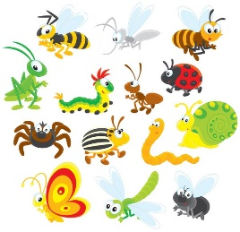  Can you write some simple sentences starting with the same sentence starter? You could pretend to be different insects. You the images of insects to  help you..  ‘I am a _______’  ‘I am a _______’  Refer to ‘I am’ sentences  on the website. |  | Topic - Knowledge & Understanding  Use the story as a stimulus and look at the life cycle of a butterfly.  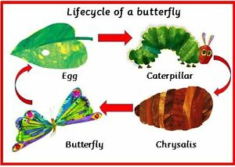  Caterpillar – chrysalis – butterfly. Draw a life cycle and label it. Can you discuss the stages of the life cycle?  Which other insect or  animal has a life cycle?  - Refer to link:  - https://www.natgeokids.com/nz/discover/animals/insects/butterfly-life-cycle/
Thurs | Focus on the sound ‘oa’  Watch the video all about the digraph ‘oa’.  https://www.youtube.com/watch?v=hBFFUCraDt8&list=PLuGr6z2H2KNG4XgGr7UylwowIcDLr-T-k&index=15  After watching the video, get a piece of paper and a felt tip pen. Draw a line down the middle {like below} and see if you can write the words with ‘ai’ and ‘oa’ in them on the correct side…  oare  ai here |  | Topic - Expressive Arts & Design & Knowledge & Understanding  Look at the internet and watch short videos about life cycles of different insects and animals. Refer to the link below and look at lots of other life cycles that you can learn about and teach your Mummy and Daddy about the different insects and animals with life cycles.  You can draw a different life cycle. What about a frog life cycle?  https://www.bing.com/videos/search?q=life+cycles+for+early+years&FORM=HDRSC3 |  | Numeracy- Ordering caterpillar numbers  Practise counting to 20. You can clap, hop, jump, wiggle, do star jumps – whatever keeps you active and happy!  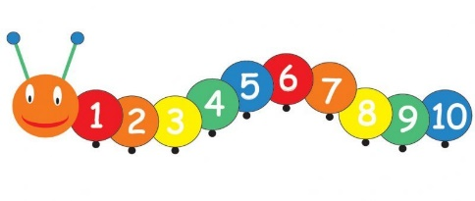  Today we can practise ordering some of these numbers. You can look at the game ‘topmarks’ caterpillar ordering, then order the numbers to 10 or 20 {depending on how brave you are feeling !}  Refer to link: https://www.topmarks.co.uk/ordering-and-sequencing/caterpillar-ordering  Refer to numbers to 20 worksheet on website
Fri | Recap all sounds revisited this week.  ee oa igh ai  Write as many words as you can with these digraphs in them. Use the worksheet attached and play a bingo game with your Mummy or Daddy.  Refer to the bingo game on website |  | Numeracy -  It’s Friday everyone!  Take a look at the White Rose Maths hub {if you haven’t done already}. It’s brilliant and has lots of amazing ideas based around ‘The Hungry Caterpillar’. Lots of ideas about using painting and symmetry. Maybe do some butterfly symmetry painting…  https://whiterosemaths.com/homelearning/early-years/ |  | Topic - Expressive Arts & Design  Learn a song about a butterfly life cycle. Listen to the caterpillar song sung by Mrs. Atkinson. Can you sing this song and practice it until you are happy that you can remember it all by yourself?  Go on, have a go! I’m sure you  can sing it so much better  than Mrs. Atkinson!  Refer to the song on the website

