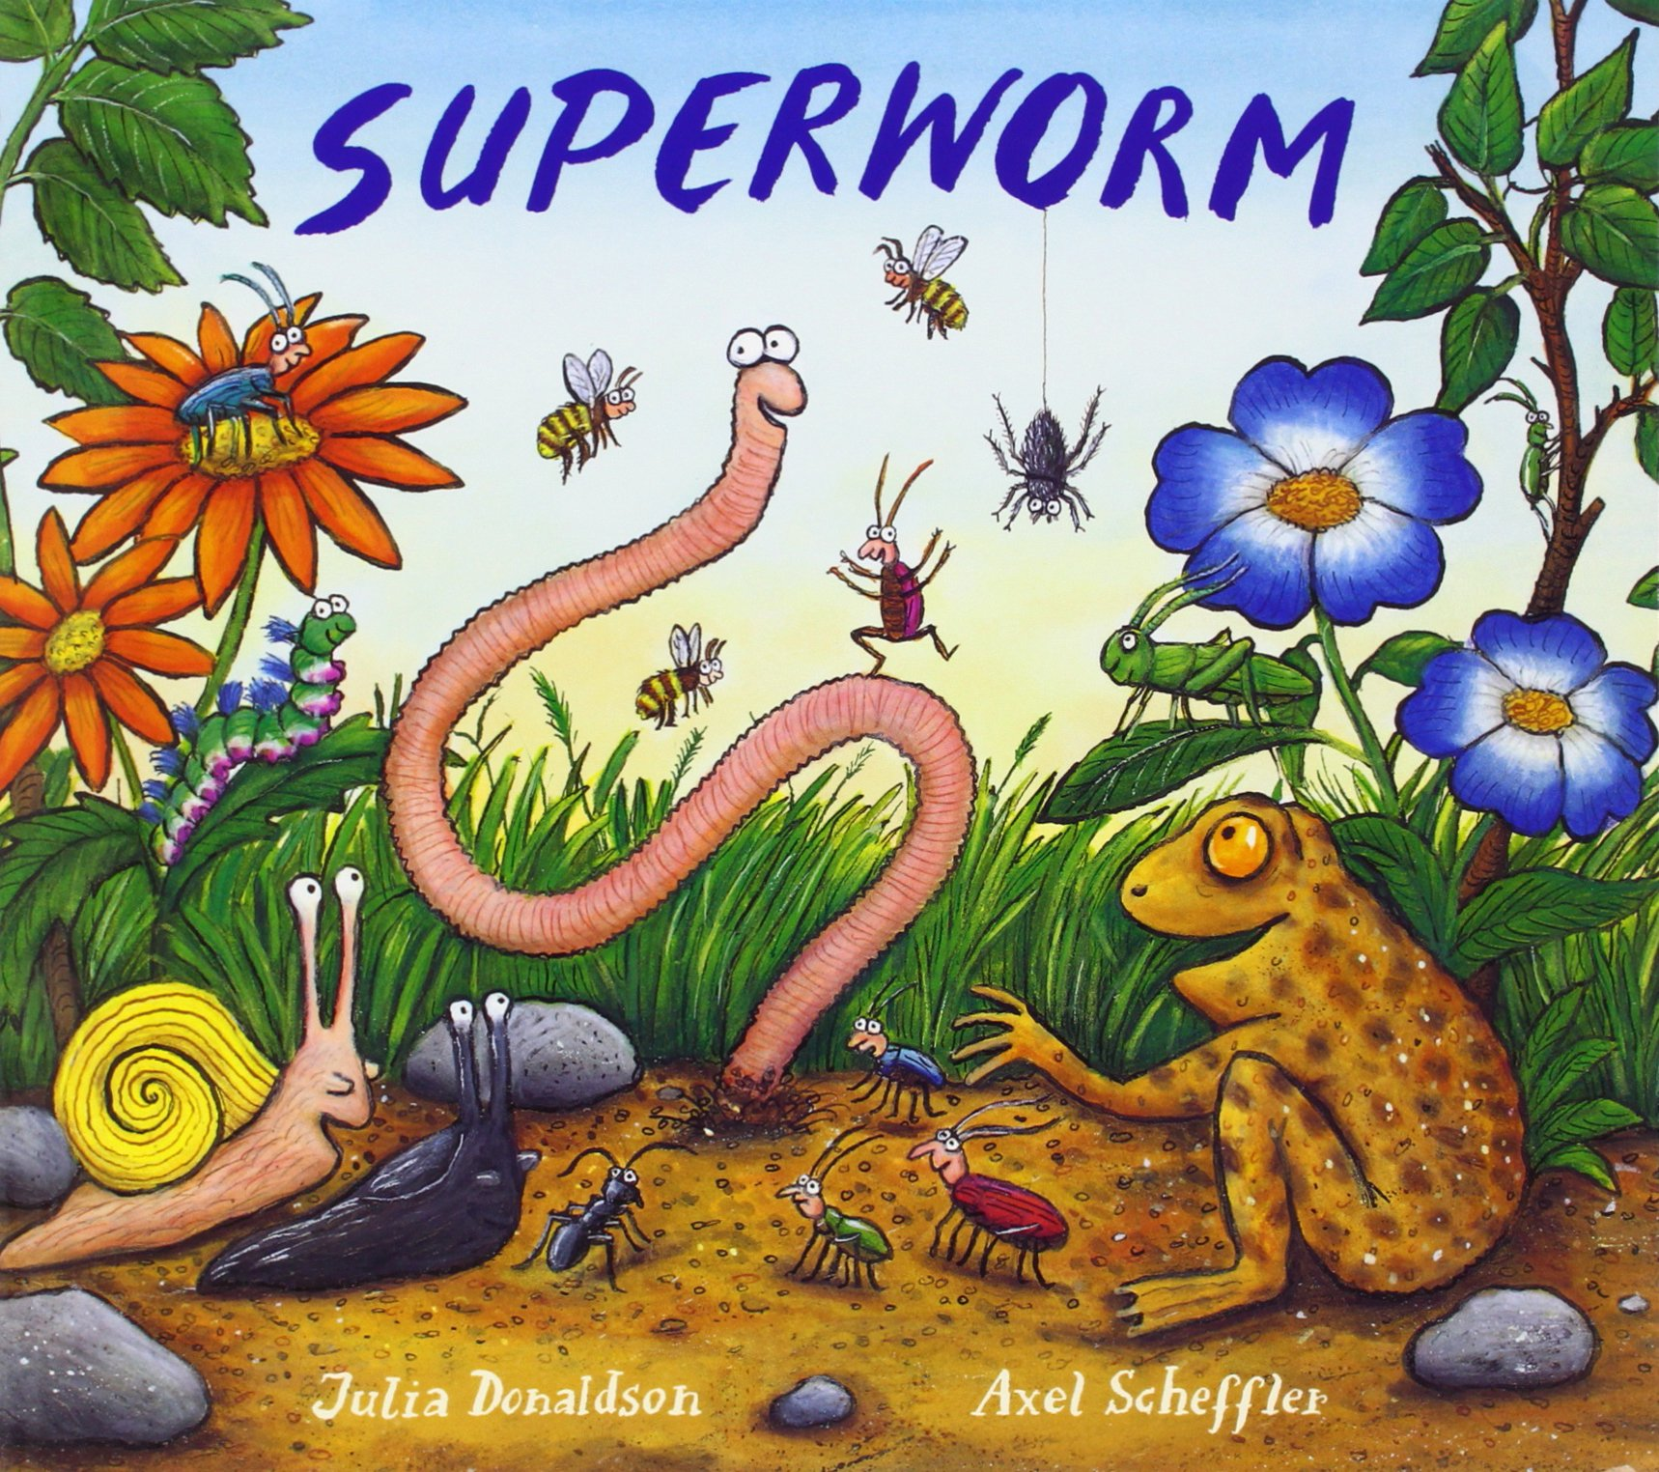
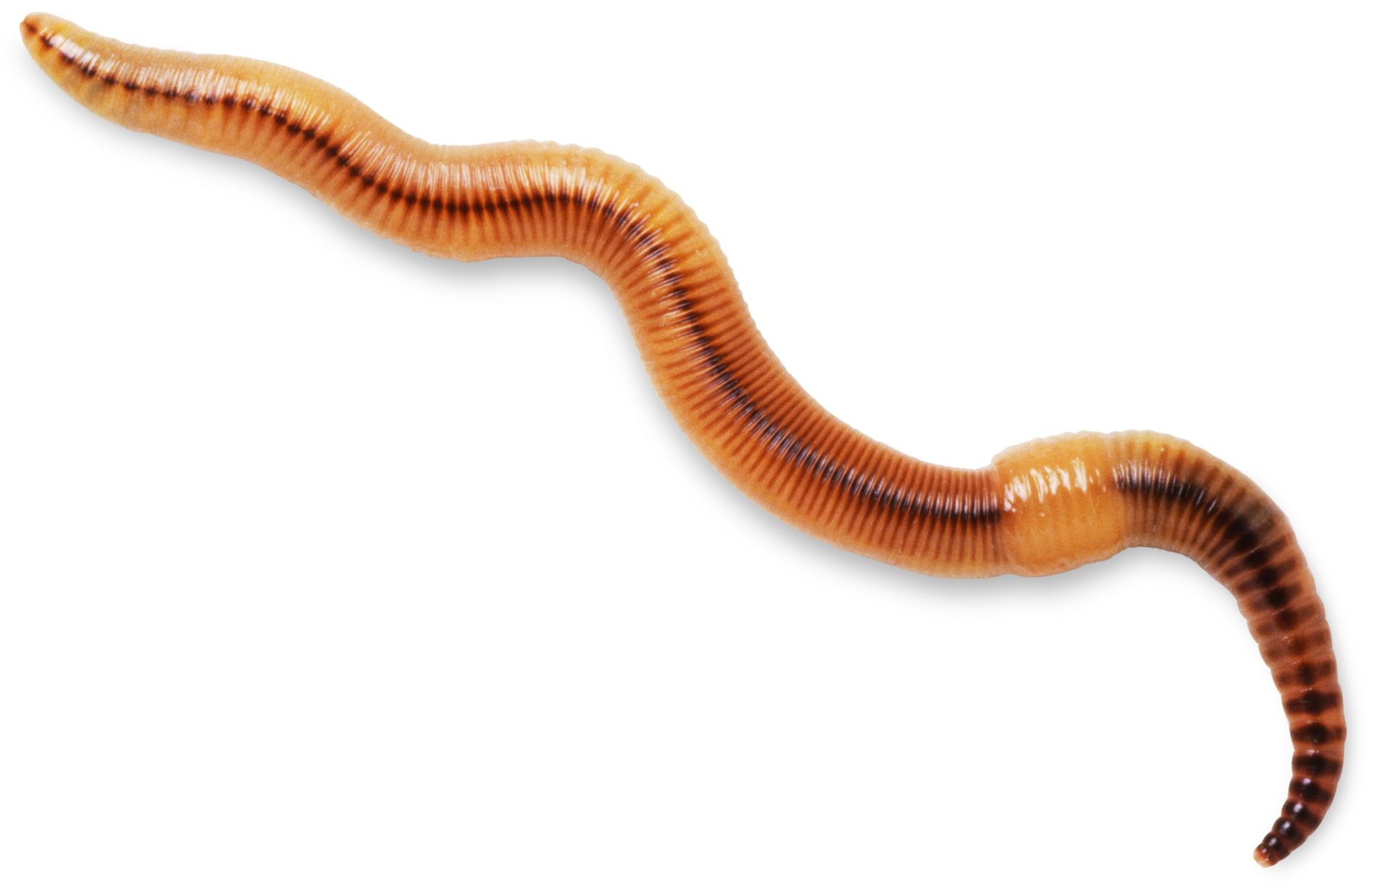
Foundation Home Learning Plan Week Beginning 4th May, 2020

Hello Parents and Children!
We have decided to stick with the minibeast theme this week and continue with the same author. This week, we shall base many of our teaching activities on the story, “Superworm” by Julia Donaldson. Again, as we said last week, this is just a guide. Please do not feel you have to stick to it rigidly. Most importantly, have fun and if your child’s learning takes off in another direction, we would love to hear all about it! Please keep your wonderful emails and photos coming. We love reading them!

Activity 1 Daily Phonics.  At the start of daily phonics sessions, please recap all letter sounds and action words in their books. Then recap reading simple 3 or 4 letter words eg jug, zip, chin, ship, sail, boat. |  |  | Activity 2 |  | Activity 3
Mon | Focus on the sound ‘ar’  Introduce todays phoneme ar, look at the grapheme, say it with the action and look at which two letters make the sound. Can they write it? Can children think of any words containing the sound? Write these down together.  Make a bingo game with ‘ar’ words in and play bingo- see who is first to tick all of the words. park, car, farm, tarn, bark, dark, barn, mars, bar, tar. Afterwards, choose three of the words from your bingo board and write a sentence with it in, remembering finger spaces and full stops. “I went to the park.” |  | Literacy  Listen to the story ‘Superworm’ read by Miss Webb, or read with a sibling or parent if you have your own copy at home.  Talk about what happened in the story. Ask questions such as: Who do you think were the good characters and the bad characters? What kind of superpowers did Superworm have? What things did he do to help the other animals? How did the other animals save Superworm? Can your child choose their favourite part of the story and draw the scene and write a couple of sentences about it. “I liked it when the other animals saved Superworm.“ |  | Topic - Expressive Arts & Design  Make puppets for some of the characters from the story. (Superworm, Wizard Lizard) and have your own little puppet show!
Tues | Focus on the sound ‘oa’  Look at the grapheme, practise saying the sound with the action and try writing it making sure the letters are written in the correct order. Make some ‘oa’ words on coloured card or paper and cut them up into sections (b / oa / t). Say a word and ask your child if they can fix the word together like a jigsaw, in the correct order. Suggested words: boat, coat, goat, moat, soap, toad. Ask your child to write a silly sentence with each of the words in. |  | Numeracy- measuring length- worms  If you have playdough or plasticine, make some of your own worms that are different lengths. Put them in length order. Use words such as long, longest, short, shortest whilst playing. Use a ruler or cubes to measure each worm and write down their length in your exercise book. |  | Literacy  Ask your child if they can pretend to be Superworm and write a thank you letter to the animals for saving him from Wizard Lizard. Talk about some of the things we would write in a letter. Remember to use finger spaces and full stops and read back your letter to a parent.  (To ____  Love from ____)
Wed | Focus on the sound ‘ch’  Look at the grapheme and practise saying it and writing it. Can your child think of any words containing the sound?  Put a selection of ‘ch’ words in a bag and play ‘Pass the musical bag’. When the music plays, pass the bag back and forth, and when the music stops, that person picks out a word and reads it out, whilst the other person writes the word on their whiteboard/paper. See if you can spell them correctly and write a sentence with each of the words in too!  Suggested words: chop, chick, chicken, chips, chin, much, match, such, chest, chat, cheese |  | Literacy  Look back at the part of the story when Superworm is using all of his super skills. Talk about what superpowers you would have and why. Write down all of your super powers and draw yourself as a superhero! |  | Topic - Knowledge & Understanding  See if you can find out some information about different minibeasts, either using the computer or a non-fiction book. Choose a couple of your favourite minibeasts and make your own fact book about them. If you want more to do, print off the Twinkl minibeast sheets and sort the bugs into the correct columns (wings, no wings, spots, legs etc).
Thurs | Focus on the sound ‘sh’  Show your child the sound and write it down, taking care with forming the letter ‘s’.  If you are able to, on the laptop or iPad, play the pirate game on phonics play. Type in some real ‘sh’ words and some nonsense ‘sh’ words. Each time a new coin comes up, ask your child to read the word and sort it into the bin or into the treasure chest!  Suggested real words: ship, shop, shed, fish, sheep, shack, shut  Suggested nonsense words: shib, shec, mosh, shod, fush |  | Topic - Expressive Arts & Design & Knowledge & Understanding  Can you design your own minibeast hotel/house for Superworm and friends. Think about the kind of conditions that minibeasts like to live in. Draw your design first and label the different parts of your hotel/house and write a list of the different natural resources you may use. Go outside and gather the resources you are going to use and begin to build! Think about the structure and how it will stand up against certain weathers. Take a picture of your super creation! |  | Numeracy- addition with bugs on leaves  Make some of your own leaves and minibeasts. Use a dice to roll a number and count that many bugs on to a leaf, then repeat and count the bugs on to a different leaf. Add the amount together by either using a number line to count on, or count all of the bugs by touching them. Write the total amount down, being careful to form your numbers properly.  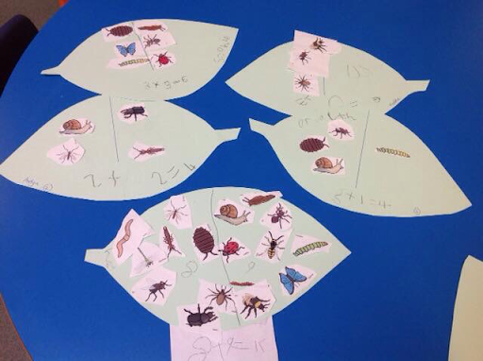
Fri | Recap all sounds revisited this week.  Look back at all the sounds visited this week and write them all down. On a big piece of paper or a whiteboard, split the page into four sections and write each of the sounds in each section. If you can beforehand, gather some objects that have each of the sounds in and hide them around the house. With your paper/whiteboard, go and find them all and write them in the correct sections. Take a picture of all the words you write down.  Suggested objects to hide: boat, coat, car, farm, chips, chocolate, fish, sheep, shed, |  | Numeracy - minibeast pictograms  Choose four minibeasts from the story. Draw them across the bottom of your book/paper and write numbers up to 10 up the side. Can you ask all of your family members what their favourite mininbeast is, maybe you could ask Grandparents over Facetime too! See which minibeast is the most/least popular!  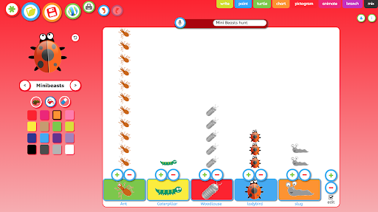 |  | Topic - Expressive Arts & Design  On Twinkl, use the ‘Top Ten Minibeast’ craft pack and using resources that are readily available to you, make your own minibeast. Don’t forget to take a photo!  