Lesson 5: How is the baptism of Jesus used today?

Christians today still use the ideas of Jesus’ baptism is their services. Throughout this lesson, I would like you to compare how the practices have either stayed the same or changed. If you have been baptised you may want to have a look at your photos or talk to your grown ups about the ceremony that took place.

Task 1) Why do you think baptisms still happen today?

Task 2) During baptisms the Lord’s Prayer is said.
Have a look and remind yourself of the words, why do you think this is used?
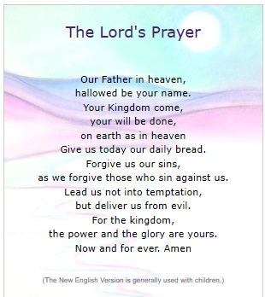

Task 3) Spot the difference!
Some christians choose to baptise their children when they are babies, know as infant baptism. Others choose to become baptised when they are older, know as adult baptism.
Using the video, complete the comparisons on the Venn Diagram. (Remember the overlapping part are the bits that are the same and the outer parts are for the differences)
https://www.bbc.co.uk/teach/class-clips-video/religious-studies-ks2-baptism/zm32nrd 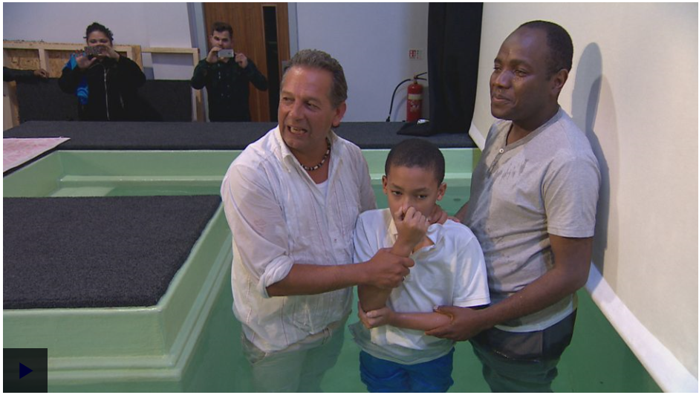

Infant Baptism Adult Baptism

Task 4) How is the baptism of Jesus used today?
Looking back at what you have learnt this lesson, try to answer the key question.

