Lesson 4: How is the Trinity shown?

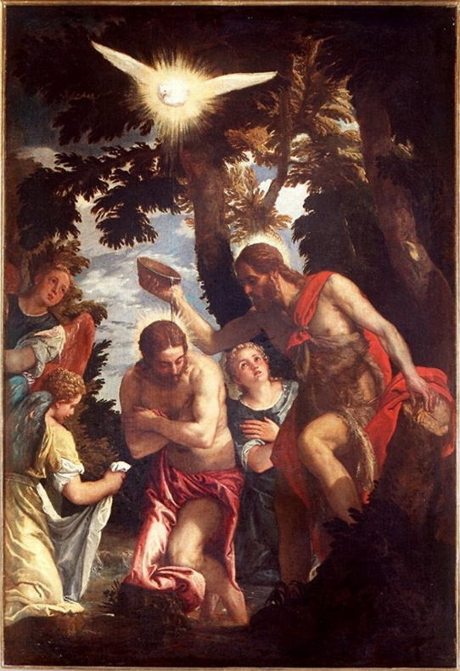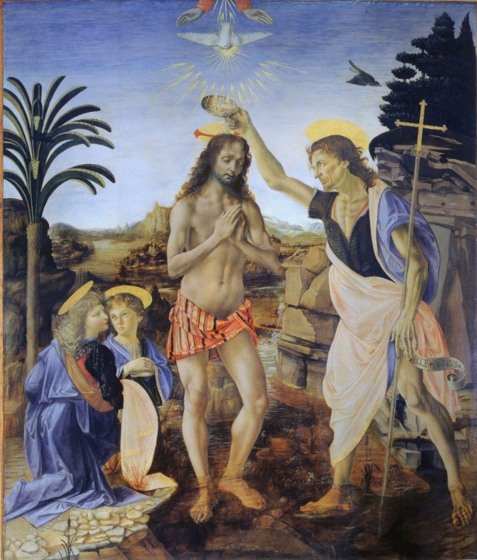
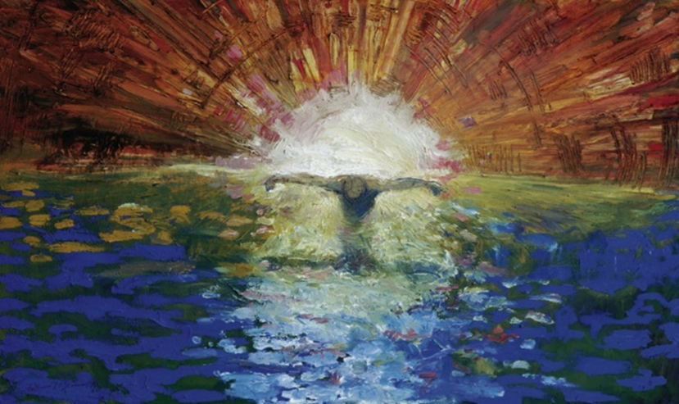

Here are three representations of the Baptism of Jesus. Have a close look and on the next page, fill in what you notice about the three pictures.

 | Painting 1 | Painting 2 | Painting 3
How is ‘God the Father’ shown in the image?
How is ‘God the Son’ shown in the image?
How is ‘God the Holy Spirit’ shown in the image?
What else do you notice about the image?

Do you think anything is missing?
What are the most important parts of the image?

Challenge: (Mrs Simmonds’ Prize box competition- I am aware I will have to give these once we return to school. I will be asking your teachers to choose the most creative designs)
Using a medium of your choice, (Lego, paint, crayons, computer etc.) create your own image to represent the Baptism of Jesus. Use the information you filled in above to help you check what needs to be included. Remember t think about the Trinity.

