Lesson 3: How does Jesus’ baptism show the Holy Trinity?

The prefix tri- means three;
tri-angle= three sided shape with three angles.
Tri-cycle= three wheels
What do you think Trinity means?

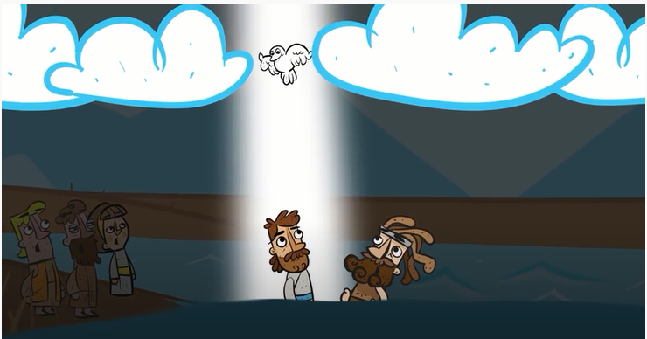
Last lesson, you learnt about Jesus’ baptism. What happened at the end of the gospel?

https://www.youtube.com/watch?v=_VMNO2MAmwA (if you need to recap)

Using the PowerPoint on the Holy trinity can you complete the following:
- A Christian believes that the doctrine of the Trinity is :

- God is described as God the Father because Christians believe:

- God the Son refers to how Christians believe:

- God the Holy Spirit refers to how Christians believe:

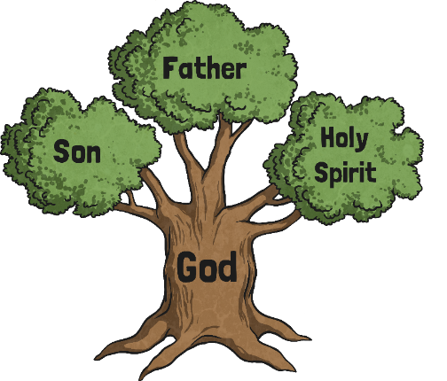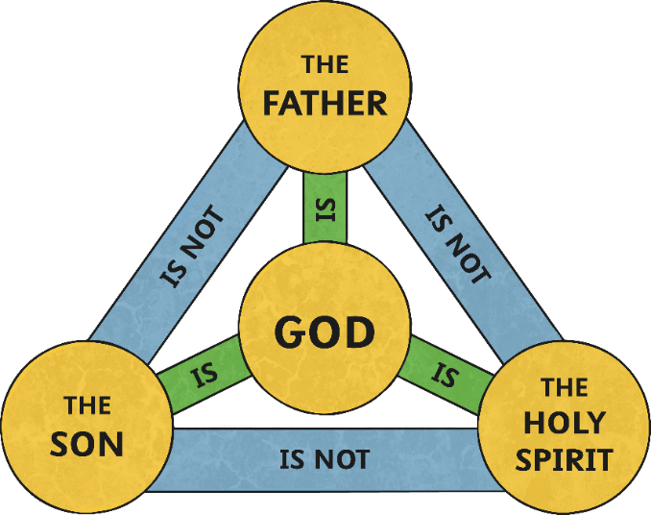
Above are ways the trinity has been shown by Christian believers.
Your challenge this week is to design a symbol to help explain the beliefs of the Trinity. Be creative and I hope to see some on our All Saints’ All-Star Gallery.

