Why is water so special?

- What ways do we use water? Write down how you use water.

- What is the meaning of water? (e.g. life-giving, powerful,reflective)

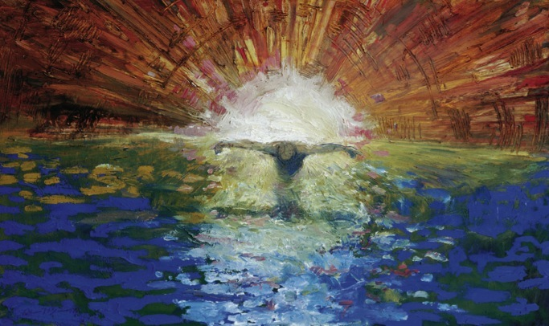

- Have a look at the picture above, What do you think it shows us? (I will reveal in the next lesson)

- Talk to an adult about a time when you have used water, why was it so important? (this could be after a race to drink, to get clean or make something clean for example)
Design a poster to explain the ways water is important to us all.

