UKS2 suggested weekly plan - W/B 27/4/20
Outside of English and Maths, we will ask children to focus their attentions on one other subject per day, as we feel this is realistic in the current situation. This week’s additional subjects are Science, DT and Computing . That said, this does not mean that children/parents/carers who wish to look at other subjects cannot do so. Please feel free to continue or finish any aspects of work suggested last week.
Below is our suggested timetable for the week.
 | 9:00-9:30 | 9:40 – 10:30 | 10:45 – 11:45 | 13:00 – 14:00 | 14:00 – 15:00  Optional extra  PSHE - This stands for Personal, Social and Health education. It focuses on developing the knowledge, skills and attributes to keep children and young people healthy and safe and to prepare them for life and work. Currently, we feel it takes on even greater significance.  As part of a Parent Pay e-mail, sent by Mr Cooper, on 6th April, there was a resource file attached, named ‘Jenby’s in Schools’.  This booklet has a range of PSHE-themed activities, some of which have already been done by a few children.  If you no longer have this e-mail, we can re-send a copy.
Monday | PE | Maths | English | Science
Tuesday | PE | Maths | English | DT
Wednesday | PE | Maths | English | DT
Thursday | PE | Maths | English | Computing
Friday | PE | Maths | English | Computing
Details of this week’s learning

PE - Joe Wicks (9am) https://www.youtube.com/user/thebodycoach1

Maths - White Rose Maths online lessons and activity sheets. Answers also available. It is important to watch the short tutorials available each day to accompany learning. https://whiterosemaths.com/homelearning/ Children to start on ‘Week 2’, ‘Lesson 1’.

Monday - Week 2 lesson 1 Year 5 – Rounding decimals Year 6 – Calculating scale factors
Challenge: http://www.iseemaths.com/lessons56/

Tuesday - Continue on WRM – lesson 2 Year 5 – Order and compare decimals Year 6 – Ratio and proportion problems
Challenge: http://www.iseemaths.com/lessons56/

Wednesday - Continue on WRM – lesson 3 Year 5 – Understanding percentages Year 6 – Measure with a protractor (if you do not have a protractor miss
out question 3)
Challenge: http://www.iseemaths.com/lessons56/

Thursday - Continue on WRM – lesson 4 Year 5 –Percentages as fractions Year 6 – Introduce angles
Challenge: http://www.iseemaths.com/lessons56/

Friday - Continue on WRM – lesson 5 Year 5 – Equivalent FDP Year 6 – Calculate angles
Challenge: http://www.iseemaths.com/lessons56/

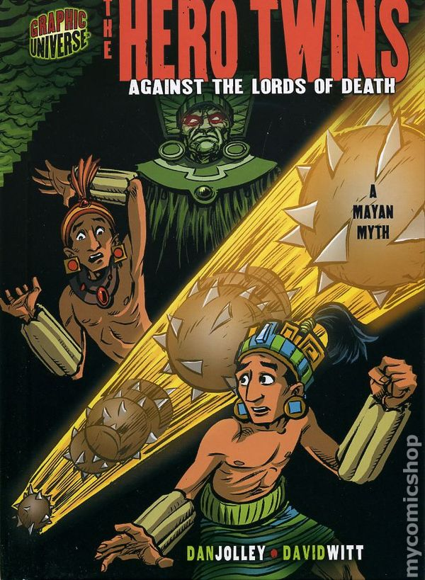
English
This week’s English work links to our new Theme – The Ancient Maya. Hopefully, you have had chance to already find out some information about the Maya people. Though it will help if you have, don’t worry if you haven’t.

The Maya lived in Central America, across countries from Guatemala to Belize. Like many cultures, they had a range of myths and legends, which told of their way of life. One of these was ‘The Hero Twins’. Like in many stories of this type, there are several versions written. There are some similar, while others are different. The version we are going to look at is called ‘The Hero Twins against the lords of death’, pictured on the right.

We have attached a pdf copy on the home-learning area, so you don’t need to go and buy it (unless you want to).

Your work can be written in your home-learning books. Good luck!
_______________________________________________________________________________________________

Monday - Prior to looking specifically at The Hero Twins story, think about the Maya in general. Gather as much information as you can about the Ancient Maya, recording it in bullet points. This could be information relating to where they lived, what they believed in, what foods they ate etc. We have attached some resources to the home learning page in case you are having difficulty carrying out research.

Tuesday/ Wednesday - Produce a non-chronological report (information leaflet) on the Ancient Maya. Children from both Yr5 and 6 should be familiar with the writing conventions associated with this genre of writing, from writing an introduction to introduce the writing, to subheadings, to adopting an impersonal tone.
Producing a plan for this may be sensible.
Year 6 children could challenge themselves to include passive sentence structures for effect.

Thursday – Look carefully at the front cover, before answering the following questions in full sentences.
What do you predict will happen in this myth?
Write a paragraph predicting what you think might happen in the myth.
Read the comic.
Q1 – There are several morals to this myth. State one, justifying your answer.
Q2 Why do you think that the author has chosen to present this myth in a comic book format?
Please support your answers with evidence.
Now generate at least one question of your own that you would like answering. For example, Why are they wearing those unusual clothes

Friday – Mini SPAG challenges

- Generate 3 complex sentences linked to The Hero Twins. Remember to use/mark subordinating conjunctions.
- Write two sentences about a character in The Hero Twins. One must use ‘challenge’ as a verb. The other must use ‘challenge’ as a noun.
- Find three synonyms of the word ‘hero’ and five antonyms of the word ‘hero’.
- Year 6 children could challenge themselves to write three sentences linked to The Hero Twins, where they appropriately use a semi-colon.

Science (Monday) - We will be challenging the children to complete some STEM challenges. STEM is a curriculum based on the idea of educating students in four specific disciplines — science, technology, engineering and mathematics (In case you didn’t know).

Can you build a paper structure that can hold a text book at least 30 cm above a tabletop.
You can use whatever type of paper you can find at home, but make sure to ask for permission before you go raiding cupboards and drawers!
There are lots example videos online, so if you're struggling for inspiration then search for some more videos to help you get started. Be as creative as you can be, and make sure you email your videos of your courses. Good luck!

DT: (Tuesday/ Wednesday) (Mayan Cooking challenge): Though the children may know little about the Ancient Maya so far, a chance to do something practical, potentially with all the family, may well be appreciated at this time.
The Ancient Maya’s diet consisted of staple foods, including maize and corn. That said, they are known to have eaten the following foods as well: avocado, chilli peppers, forms of chocolate (yum), honey, pumpkin, sweet potatoes and tomatoes. There are others, too, though some are a little obscure!
We ask that the children think about these ingredients, before creating their own single recipe to make themselves. It could be a starter, a main, a sweet, or even a drink.
Once children have decided on their creation, they can create a set of clear instructions, before making and probably eating the final product.
Instructions can be written in children’s home-learning book. As always, we would love to see pictures of the final delicious delights.

Art (Wednesday) - If you didn’t get chance to produce an illustration for our book quiz it would be great if you would have a go.
You need to produce an illustration, which is a clue to the title of a book. Use your imagination and try and cover books for children of different ages. Please take a picture and email it to your class email.

Computing (Thursday/ Friday) – (coding challenges) We would like you to have a go on a programme called BBC Micro:bit. You will be able to design codes that determine what a microbit does. There are two set tasks of creating a flashing heart and a smiley face but then it is up to you to have fun and be creative.
We have attached a PDF to the home learning page explaining which website to use and the challenges we would like you to do.

A further useful note – BBC Bitesize are generating daily content linked to different subjects. We’ve seen some of the lessons, which you could look at if you are needing any extra work.
https://www.bbc.co.uk/bitesize

