Lesson 2: How is water important to Christians?

In the last lesson, I asked you to think about how important water was and How it was useful to you. Throughout these tasks it will give you clues, to help explain what the artwork was all about. Did you guess right?
This week, I’d like you think about how water is used in the Christian faith. Use the bubble below to brainstorm your ideas.
WATER

Before we dive further, we need to think about the term ‘Gospels’. There are four key Gospels and these are letters and biographies which tell us about the life of Jesus. They have usually been written by the key figures in Jesus’ life; his disciples. This week we are focusing on one of them; Matthew Chapter 3:
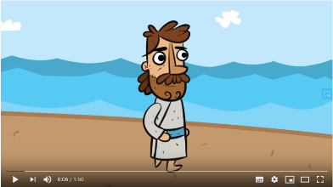
https://www.youtube.com/watch?v=_VMNO2MAmwA

Watch the clip and colour in the words you hear in the story. Which one is NOT used in the clip?
Dove | John | God
Peace | Baptise | Water
Holy Spirit | Jesus | Chosen one
Saviour | River | Dove

What part did water play in the story?

What happened after Jesus rose out of the water?
What could this symbolise?
Key task:
Create a comic strip of the story of the Baptism of Jesus. Remember to think about what the key point and symbols of the story are?
Complete the following sentence:
Water is important to Christians as it symbolises

