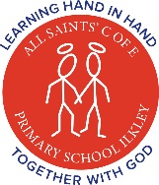
Home Learning – Reception - Week Beginning 20th April 2020

Please use these ideas to support your child with their learning this week. Please don’t forget that there are many more additional ideas on the foundation stage home learning page !!
Phonics Learning | Numbers | Literacy Reading | Literacy Writing
This week we would like you to focus on:  CVC words and Digraphs:  ai and oa  {rat, bat, sun, fun, leg, beg, win, fin, got, hot, cot, top}  {rain, pain, train, chain, stain, drain, boat, coat, moat, float, moan, loan, goat} | This week we would like you to focus on:  Numbers to 15:  1,2,3,4,5,6,7,8,9,10,  11,12,13,14,15  Children get a little confused sometimes with the ‘teens’ numbers! | This week we would like you to:  Read or share a story every day!  Ask your family questions about the story.  Oxford Owls have some brilliant ideas with storytelling and making up your own stories! Take a look! https://www.oxfordowl.co.uk/for-home/find-a-book/library-page/ | This week we would like you to focus on:  Writing simple sentences!  Please have a little look at some of your action words and see if you can remember how to read and write 5 of them!  You have your action book to help you!
Using a range of materials – chalks, paints, large paper, felt tips. Any exciting materials you have at home.  https://www.youtube.com/user/breakthruchris Great website to watch phonics videos …….with Mr Thorne! Check them out, they may support you with ‘ai’ and ‘oa’ digraph learning. | We always start a number lesson with counting and warming their brains up. We clap, hop, jump, spin, wobble our way to 20 with counting! Try it! Great physical workout too!!  https://www.topmarks.co.uk/maths-games/5-7-years/counting - Great online counting games. | Children need to also hear you read stories or listen to Audible stories. They need to hear expression and intonation and the different characters speaking. | 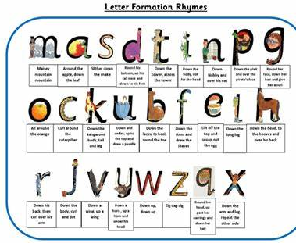  Whenever you write please try to practise letter formation, remembering to say the school phrases as you write each letter {‘m’ would be ‘maisy mountain mountain’ and so on.}
Possible lesson ideas:  - Cut up letter sounds and child to make words {both silly word and real words} | Possible lesson ideas:  - Ask your child to write these numbers {or just to 10 if they find it hard}. Cut them up and re order them. | Possible ideas:  - Read your child’s favourite fairy tale story. Role play the different characters with your child and make it fun! Use props if you can! | Possible lesson ideas:  - Write labels for things around your house {cup, door, bedroom, fan, handle etc..}
- Using letter cards, make simple 3 letter words with your child. Then ask child to close their eyes and you can jumble up the letters. Child to re order the letters to remake the words! | - Use chalks or felt tips to write these numbers in different colours. Ask what one more/less than these numbers is. | - Draw a picture of the characters from your story. Talk about the personality of each character e.g. kind, evil, sad, friendly etc. | - Practise writing your name in rainbow colours {to support the NHS}  - Mrs. Atkinson…….
- Child to hop/clap the 3 letters in the words. Adult obviously joins in! | - Hunt for numbers in the house, outside, on front doors, food jars, labels… Write them down and make a list of all the numbers. | - Design your own front cover for your favourite book! | - Choose your favourite flower and write a simple sentence about it.
 |  |  | - Pretend to be the teacher and ‘make’ your Mum, Dad, brother or sister practise the letter formation!! He he!
- Ask your child to robot talk a 3 letter word and you copy {if the adult gets the segmenting and blending wrong it can be more fun!}  www.ictgames.com/mobilePage/literacy.html Great phonic ideas to support you! | - Write the numbers to 10. Can you make these numbers in to characters?!!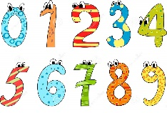 | - Make your own puppets out of a story and stick them to sticks to act out the story!  https://www.topmarks.co.uk/ Search.aspx?q=traditional%20tales Look at these traditional tales to gather the excitement! | - Draw the letters on your Mum or Dad’s back. Can they tell you which letter it is? Swap around and ask your parents to write it on your back!
- Write both digraphs on a sheet. Say a word with ‘ai’ or ‘oa’ and ask your child where the word goes. | - Cut a strip of card and ask your child to make their own number line to 10 or 15!
www.ictgames.com/mobilePage/bingo/index.html Great 3 letter word bingo game!

Topic-Science/Art/World | 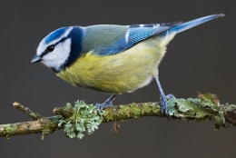  - Go for a spring walk and take photographs of all the new flowers and birds. | 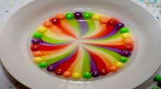  - Rainbow science experiment using skittles and water! | 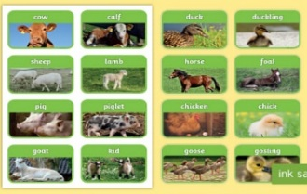  - Match the baby with the adult animal

Please refer to the wonderful websites and ideas which are also on the website for you to dip in to. There are lots of phonics ideas {sound/phoneme mats, high frequency words} and number games to play together with you child.

There is also an additional list of ‘topic’ ideas and websites to browse to provide you with more ideas to support learning at home.

In addition to this learning there is a wonderful book that we thought you might like to share with your child about the coronavirus. The link is below:
https://www.playpennies.com/books/free-dave-the-dog-is-worried-about-coronavirus-book-download-186086

We will update this home learning grid each Friday for you to use.
We hope it is useful! Enjoy!

